**List issues**

**Issue 1: City of Gosnells at heart of consolidation tsunami**

**No single development will more profoundly effect the residents and rate-payers of the City of Gosnells than the State Government’s decision to consolidate the Perth Metropolitan area in coming decades to accommodate projected population growth. The strategy comes from WAPC and all major parties are in substantial agreement. The talking is pretty much over, demonstration projects and pilot developments and those reading the wind have all already left their marks…. for better or worse.**

**In short, it’s better (even very good) for those in the central city and the Western suburbs are fighting to oppose it. For the city’s middle and outer suburbs especially to the east and its long southern axis taking in the City of Gosnells , it’s looking even more grim and there’s no sign of fight anywhere here.**

**The City of Gosnells must redirect, modify limit and impose more effective design controls on Perth’s ongoing consolidation project. I will make this a priority if I am elected to Council … and I have ideas. (insert links)**

**The images are taken from a book I am currently writing called *The Death of Suburban Perth*.**

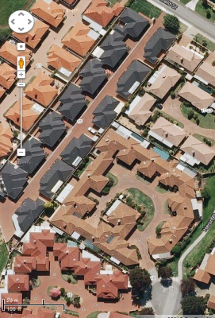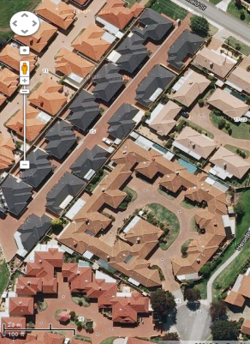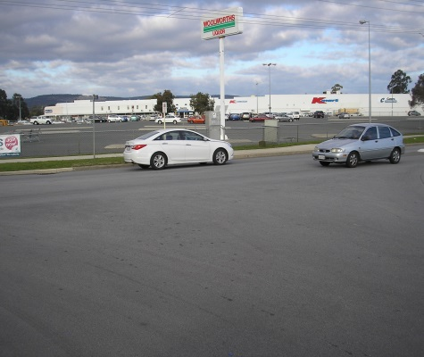

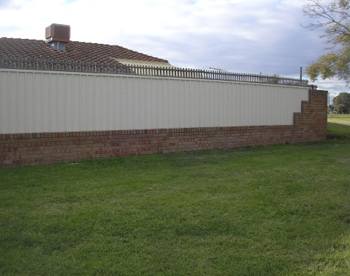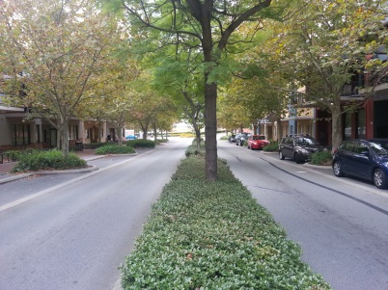

****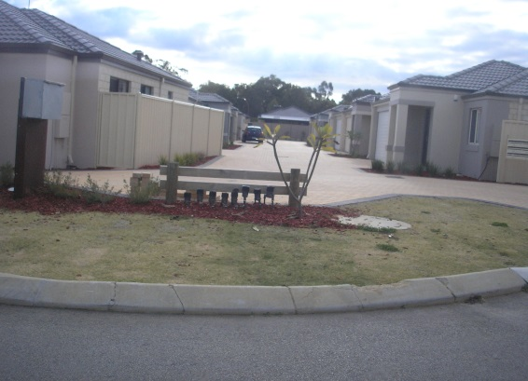

Perth’s population is likely to double and reach 3.5 million by 2050. By then, as a consequence, some 700,000 new dwellings will be needed. Where will these go, given that Perth is already spread over a vast stretches of land and is one of the lowest density cities in the world. Avoiding the various costs of sprawl is now the city’s s major planning challenge.

But how bad are our sprawling suburbs and are they worth destroying – especially for something much worse

And aren’t there other ways of dealing with city’s problem?

State Governments, whether Labor or Liberal, have for some time been concerned about transport and infrastructure costs if low density sprawl continues and have been talking about the problems - and planning city growth accordingly - for at least 3 decades. The Barnett Government’s current plan is called *Direction 2031 and Beyond* – takes us halfway to 2050 and to the need for some 325,000 new serviced home and given the hype that has attended it, pretty poor – no poorer,though than Labour’s attempt in Network City which involved even more hype.

In any event, Direction 2031 proposes to significantly cut fringe expansion by directing around half of the new required houses (150000) into the existing metro area as infill, mostly into Perth’s middle and outer suburbs. The rest (175, 000) are still to be built on the fringe but higher densities –so that most everyone coming into the housing market will be shoehorned into smaller lots. The photo above shows lots at R30 and 40 densities (meaning lots of 250 and 300 sqm). The talk is now land lots just 80 sqms in some fringe developments!

*Directions 2031* principally involves what is called urban consolidation half of it “infill” The latter means squeezing more houses into the mostly suburban spaces and fabric of our city. Again, its poor planning and likely to make many of the city’s problems worse.

Local Government planners and urban designers, and likewise academic planners in our universities are doing little to help. They lack the power, the courage or the imagination, needed. Richard Weller, formerly a landscape architect at UWA is a notable exception See especially his Boomtown 2050.

There are two ways of working out what is going on and what Governments really intend. One involves reading *Directions 31* filled as it is with the reassuring green and caring promises. Its mission statement is a classic: it aims at no less than **“**a world class liveable city that is green, vibrant, more compact and accessible with a unique sense of place.”

The alternative to reading is walking or driving around the city’s **middle and outer suburbs.** These areas will bear the brunt of government consolidation or infill plans.* Anyway, walking or driving around, one can check out new and recent residential property developments. As a former academic and now a small scale developer I do a lot more walking and looking. It’s called testing promises against realities. And on the ground, it’s not looking good.

Go have a look yourself. If you can’t take a real tour Take a cheap satellite photo tour or have a look at the photos I have assembled below. You will see what City’s South -Eastern Corridor (and the City of Gosnells is right in the in middle). Your heart should sink and you should be demanding more. Your children will be living here before long. And your young grand children playing. Where will they play? In virtual backyards?

Photo 1 shows the most popular form of urban consolidation in Perth’s middle and outer suburbs. Here we are, too roughly at the heart of the CoG. On a scale of 1 to 10 for amenity, it scores about 2. Or is that too generous? This is infill on the cheap: cheap housing cheap on (absolutely) necessary infrastructure and nothing spent on amenity. I call it low rise hyper-extensive development.

The residents here don’t need to sit outside in spring or summer in the shade provided by private garden. Not even a shared one! Every bit of open common ground is hard surface given over to car movement. Ironic, isn’t it? Given that one of the main reasons for this compression is to discourage car use. Development like this lacking any infiltration capacity also overwhelms older storm water management infrastructure. These lifeless, utterly treeless heatsinks alos challenge the CoG commitments to energy efficiency and climate change mitigation. You can’t live in these developments without heavy use of air-conditioning.

**Figure 1 Making a world class city**

*Directions 31* envisions “a world class liveable city that is but delivers this stunning display of careless consolidation

1. New Maddington – the failing low density city overhauled

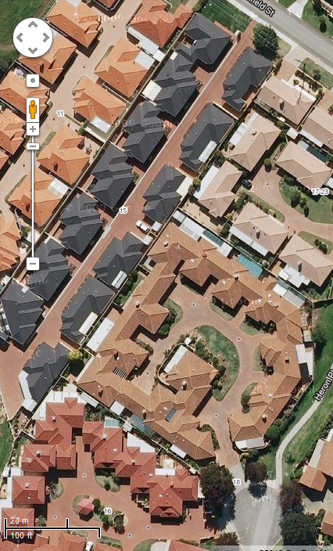

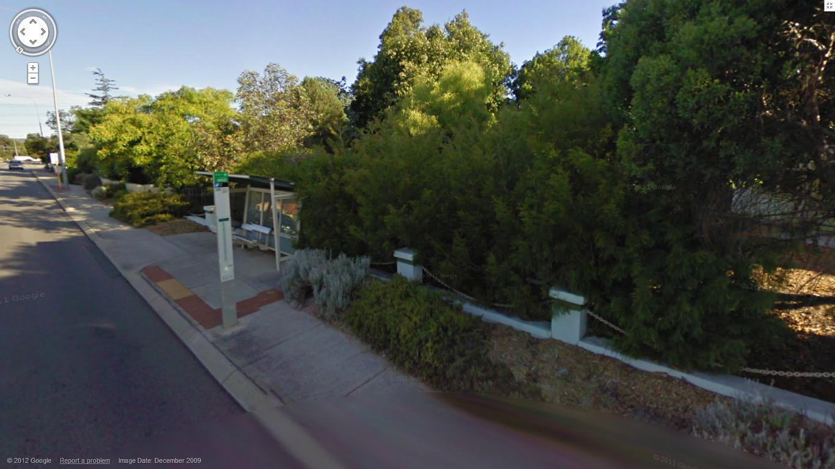

2 Old Beckenham – the failing city in need of overhaul?

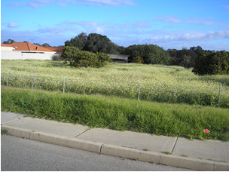

Old Maddington -

Photo 2 shows and old low density suburb on Albany Highway in the City Gosnells. My wife and I bought this half acre property and, as small scale developers, subdivided into three lots a leaving gorgeous old character house restored to former glory on one and ample tree growth and foliage across the whole. Gosnells City engineers did not like it. Their policy, I was told, is “strip and clear”. The new owners have since obliged. And this is happening all of the city of Gosnells The property in image 2 is everywhere becoming 1 and it is good because it making a “green, vibrant, more compact and accessible [suburb] with a unique sense of place.” Compact it certainly is but can you imagine places that are less vibrant or unique? Do our senior planners and politicians laugh at us over lunch when we appear to believe them? In the Western suburbs they don’t.

Photo 1 again: where, again, will our grand children play? Occasionally in treeless parks on the next block when an adult is available to accompany them? Poor suburb though Kenwick was in 1950s and 60s, that’s not how I grew up.